CREATE TABLE job_grades (
grade_level INT PRIMARY KEY,
lowest_sal DECIMAL(10, 2) NOT NULL,
highest_sal DECIMAL(10, 2) NOT NULL
);
INSERT INTO job_grades (grade_level, lowest_sal, highest_sal)
VALUES (1, 30000.00, 49999.99);
INSERT INTO job_grades (grade_level, lowest_sal, highest_sal)
VALUES (2, 50000.00, 69999.99);
INSERT INTO job_grades (grade_level, lowest_sal, highest_sal)
VALUES (3, 70000.00, 89999.99);
SELECT *FROM JOB_GRADES;
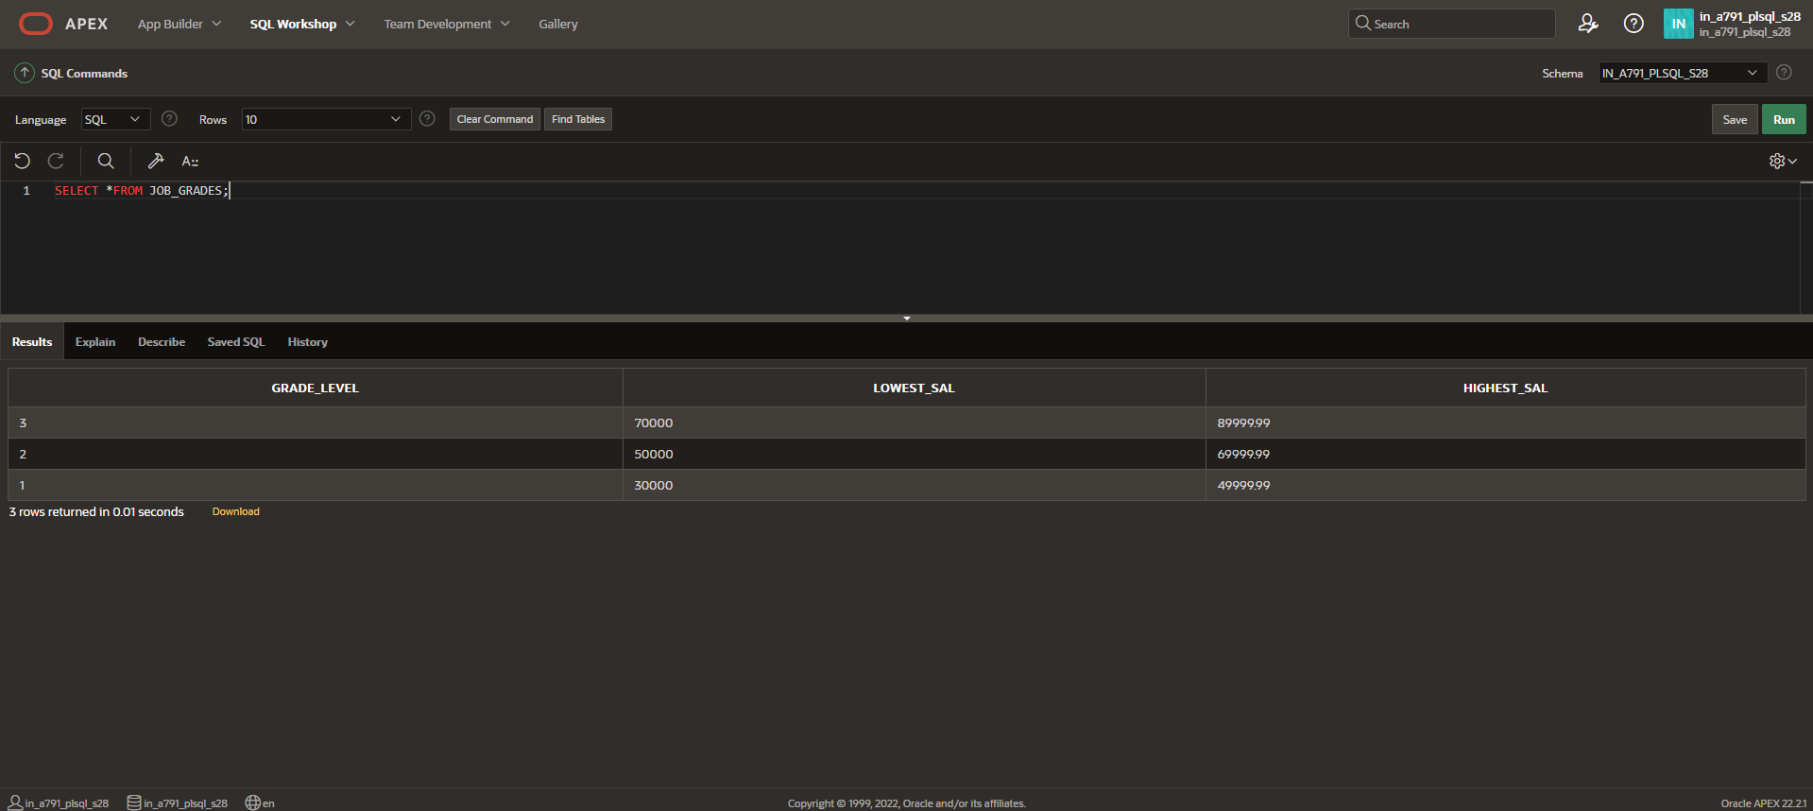

CREATE TABLE emp2 (
employee_id INT PRIMARY KEY,
first_name VARCHAR(50) NOT NULL,
last_name VARCHAR(50) NOT NULL,
salary DECIMAL(10, 2) NOT NULL,
grade_level INT,
FOREIGN KEY (grade_level) REFERENCES job_grades(grade_level)
);

INSERT INTO emp2 (employee_id, first_name, last_name, salary, grade_level)
VALUES (101, 'John', 'Doe', 45000.00, 1);
INSERT INTO emp2 (employee_id, first_name, last_name, salary, grade_level)
VALUES (102, 'Jane', 'Smith', 55000.00, 2);
INSERT INTO emp2 (employee_id, first_name, last_name, salary, grade_level)
VALUES (103, 'Alice', 'Johnson', 75000.00, 3);
INSERT INTO emp2 (employee_id, first_name, last_name, salary, grade_level)
VALUES (104, 'Bob', 'Brown', 60000.00, 2);
INSERT INTO emp2 (employee_id, first_name, last_name, salary, grade_level)
VALUES (105, 'Charlie', 'Davis', 40000.00, 1);
SELECT *FROM EMP2;
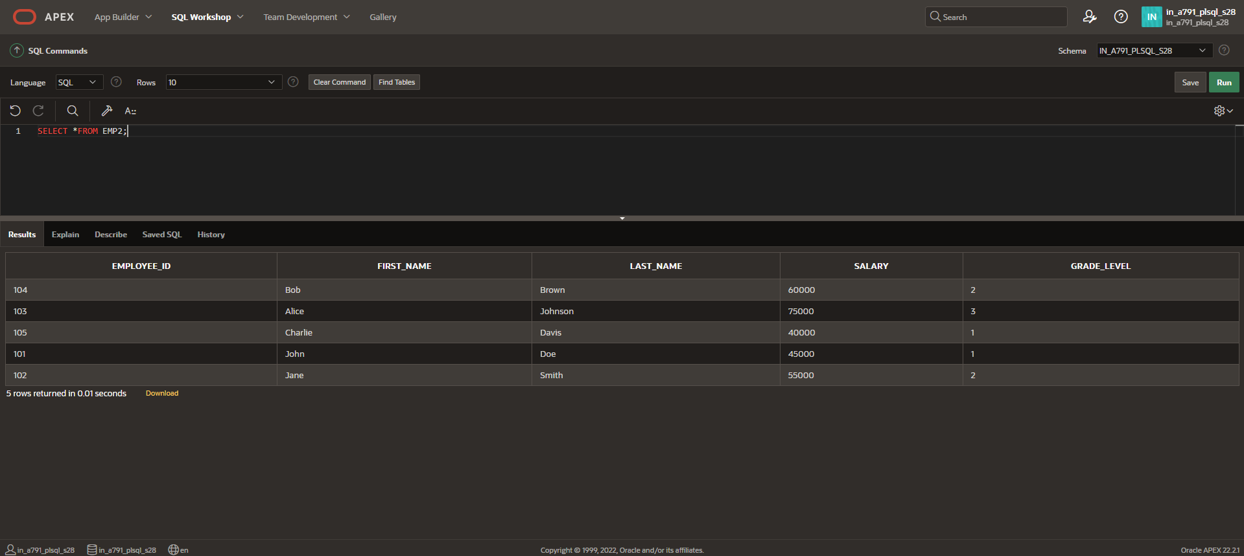

SELECT e.last_name, e.salary, e.grade_level, j.lowest_sal, j.highest_sal
FROM emp2 e
JOIN job_grades j
ON e.grade_level = j.grade_level
WHERE e.salary BETWEEN j.lowest_sal AND j.highest_sal;
